**Rust(**[**https://play.rust-lang.org/?version=stable&mode=debug&edition=2021**](https://play.rust-lang.org/?version=stable&mode=debug&edition=2021) **):**

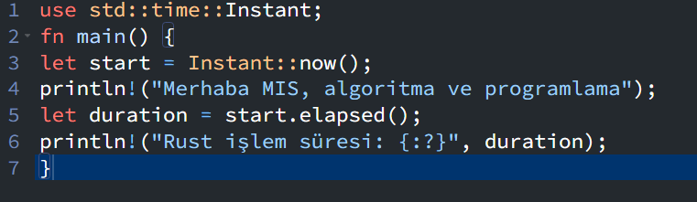

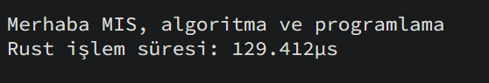

**GO(**[**https://go.dev/play/**](https://go.dev/play/) **):**

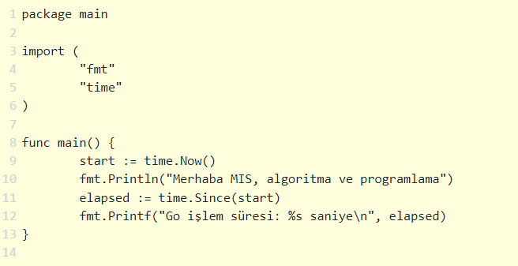

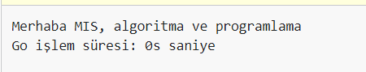

**Python(Visual Studio Code):**

**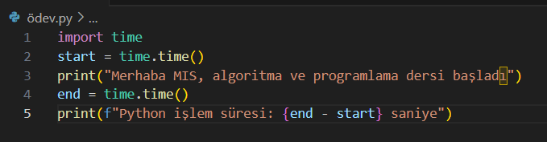**

****

**Perl(**[**https://onecompiler.com/perl/42v4nvkm4**](https://onecompiler.com/perl/42v4nvkm4) **):**

**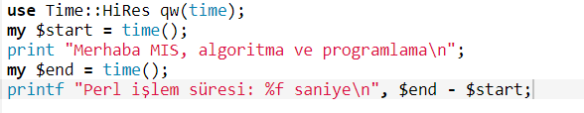**

**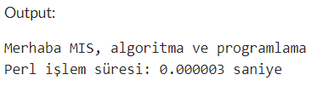**

**Ruby(**[**https://www.onlinegdb.com/online\_ruby\_compiler**](https://www.onlinegdb.com/online_ruby_compiler) **):**

**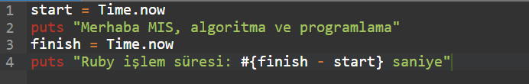**

****

**Java(**[**https://onecompiler.com/java/42v4pjbzu**](https://onecompiler.com/java/42v4pjbzu) **):**

**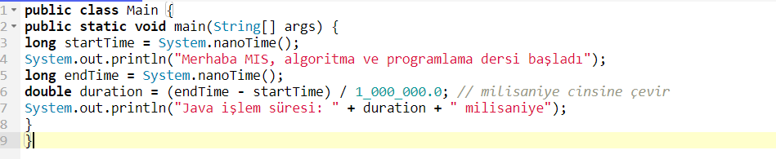**

**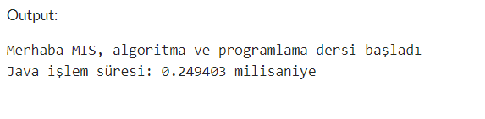**

**NodeJs(**[**https://onecompiler.com/nodejs/42v4pp5vk**](https://onecompiler.com/nodejs/42v4pp5vk) **):**

**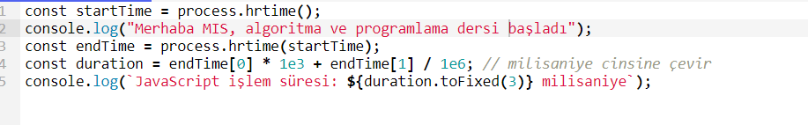**

**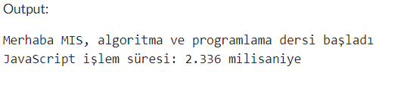**

**C#(Visual Studio):**

**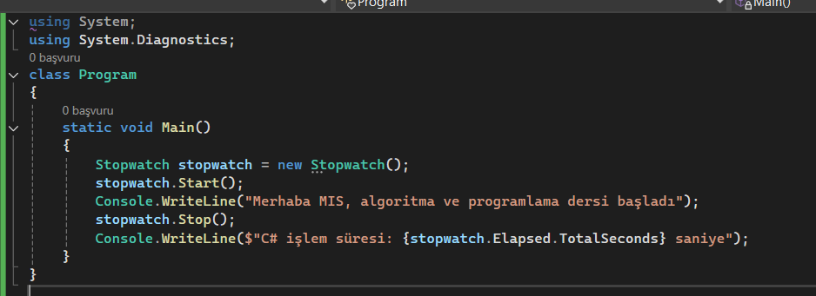**

**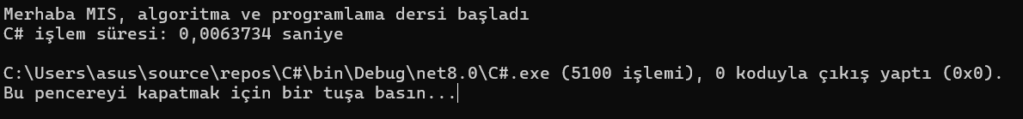**

**C++(Visual Studio):,**

**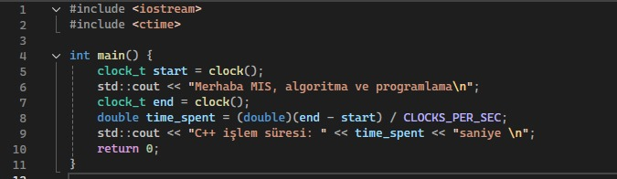**

**C:\Users\asus\AppData\Local\Packages\5319275A.WhatsAppDesktop_cv1g1gvanyjgm\TempState\13FE9D84310E77F13A6D184DBF1232F3\WhatsApp Görsel 2024-10-16 saat 23.28.42_8652b89e.jpg**

**C(Visual Studio):**

**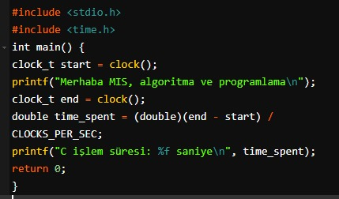**

**C:\Users\asus\AppData\Local\Packages\5319275A.WhatsAppDesktop_cv1g1gvanyjgm\TempState\74DB120F0A8E5646EF5A30154E9F6DEB\WhatsApp Görsel 2024-10-16 saat 23.33.42_72f2caf0.jpg**